Prepositions of Comparison or Contrast

🔹 What Are Prepositions of Comparison or Contrast?
# Source: AI Source: Provided by: [Data Path: Persons Table -> ID Column: 1, Name_En Column: Motasem Essam] -> From: [Chatgpt (GPT-4-turbo)] on [7/28/2025]
Prepositions of comparison or contrast are used to show similarity, difference, or opposition between two or more things.
They answer:
- How are things alike or different?
- What is being compared or contrasted?

✅ Common Prepositions of Comparison & Contrast
# Source: AI Source: Provided by: [Data Path: Persons Table -> ID Column: 1, Name_En Column: Motasem Essam] -> From: [Chatgpt (GPT-4-turbo)] on [7/28/2025]
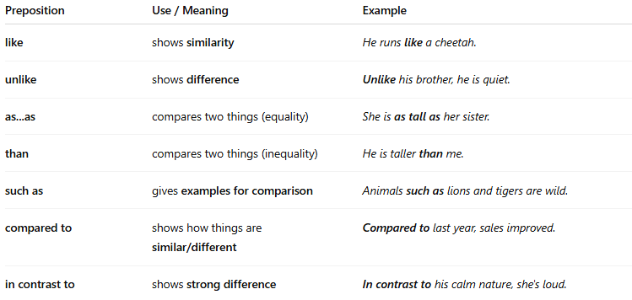
Preposition | Use / Meaning | Example
like | shows similarity | He runs like a cheetah.
unlike | shows difference | Unlike his brother, he is quiet.
as...as | compares two things (equality) | She is as tall as her sister.
than | compares two things (inequality) | He is taller than me.
such as | gives examples for comparison | Animals such as lions and tigers are wild.
compared to | shows how things are similar/different | Compared to last year, sales improved.
in contrast to | shows strong difference | In contrast to his calm nature, she's loud.

📚 Example Sentences
# Source: AI Source: Provided by: [Data Path: Persons Table -> ID Column: 1, Name_En Column: Motasem Essam] -> From: [Chatgpt (GPT-4-turbo)] on [7/28/2025]
- She dances like a professional.
- Unlike his father, he loves technology.
- This phone is better than the old one.
- Compared to the city, the countryside is quiet.
- In contrast to his past behavior, he's now very polite.

